**Assignment3**

**Yifu He 10442277**

**Question1:**

1. The below plot is drawn by R:

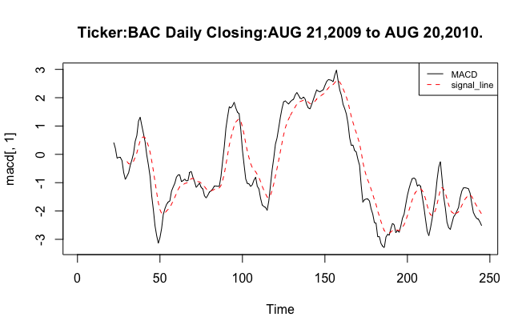

Look at the plot, our momentum trading strategy is listed below:

Go long position on BAC, if the MACD signal crossed above the signal line.

Go short position on BAC, if the MACD signal crossed below the signal line.

After counting, we can conclude that there are 15 signals and 8 of them are selling signals and 7 of them are buying.

1. The blow plot is drawn by R:

Look at the plot, our momentum trading strategy is listed below:

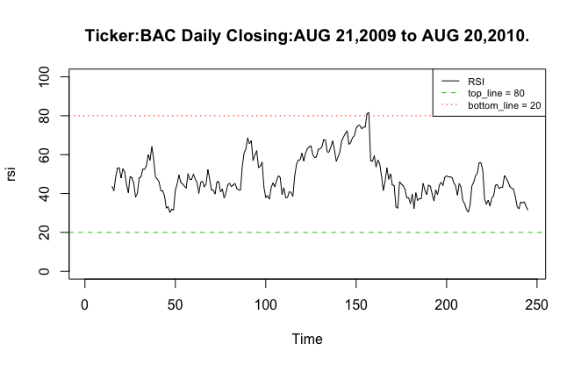

An asset is deemed to be overbought once the RSI approaches the 80 level, meaning that it may be getting overvalued and is a good candidate for a pullback. Likewise, if the RSI approaches 20, it is an indication that the asset may be getting oversold and therefore likely to become undervalued.

We only get 2 selling signals and no buying signals.

1. MACD have 15 signals which contains 8 selling signals and 7 buying singals.

When it comes to RSI , it only has 2 selling signals and no buying signal.

That means MACD is more dynamic to the price change, which may cost more transaction fees.

**Question2:**

First, we get the plot of AAclose,

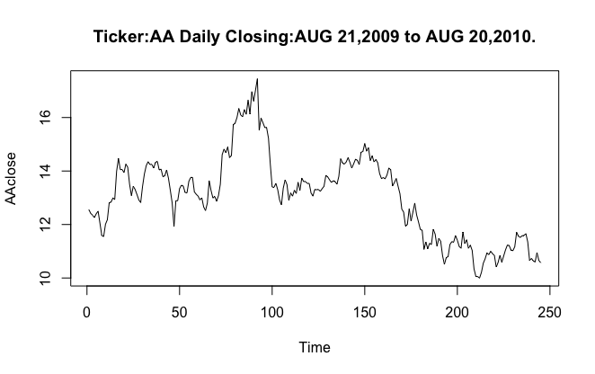

Second, we smooth the plot by EMA as the thesis of《Foundations of Technical Analysis》Andrew W.LO, Harry Mamaysky, Jiang Wang(2000),

Then we find the 5 extremes, and draw the plot of neckline. Here is the plot:

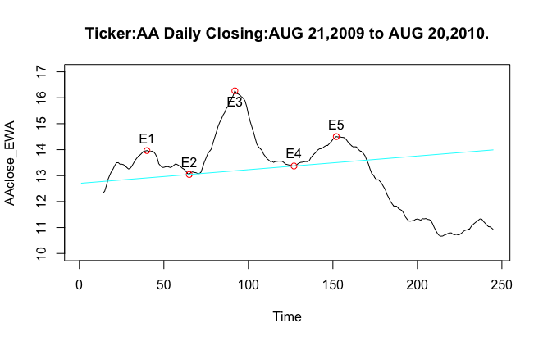

1. The 5 extremes

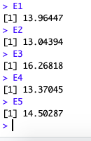

1. The neckline is the line which was drawn by E2 and E4

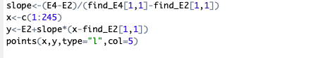

1. Strategy:

The price objective is calculated by subtracting the price at which the pattern breaks the neckline by the difference between the head and the neckline.

So calculated by R the difference between the head and the neckline is 3.779014

Then calculate the price objective, which is 8.9698681.